INSTALLATION INSTRUCTION

DEPENDENCY VERSION
Dependency | Version
node.js | v24.15.0
npm | 11.6.2
nvm | 1.1.11

INSTALLATION
- Install node.js of version v24.15.0 in https://nodejs.org/en/blog/release/v24.15.0
Search https://nodejs.org/dist/v24.15.0/node-v24.15.0-x64.msi
Once installed, verify installation with “node -v” on Command Prompt
Ensure the versions are listed like below
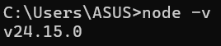
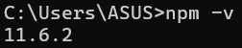
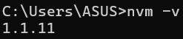

VERIFY
- Extract the downloaded project into “Documents/project-dhl2”
- Open project root folder in VS Code
(navigate via “cd Documents/project-dhl2” in terminal)

- In project folder terminal, run
“npm install”
- Confirm that node_modules folder exists once installed
Before:
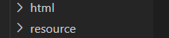

After:
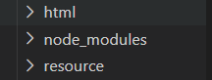

- In terminal, go to data folder with
“cd data”

- Run JSON server with
npx json-server --watch db.json --port 3000
If terminal appears like this, it works
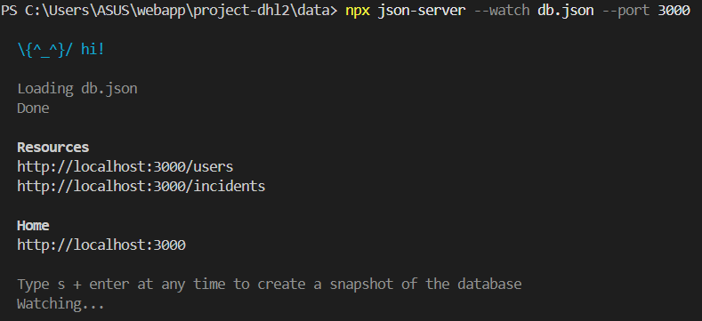

- Right-click on login.html file
- Select “Open with Live Server”
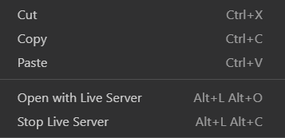

- If this webpage is displayed, that means everything works
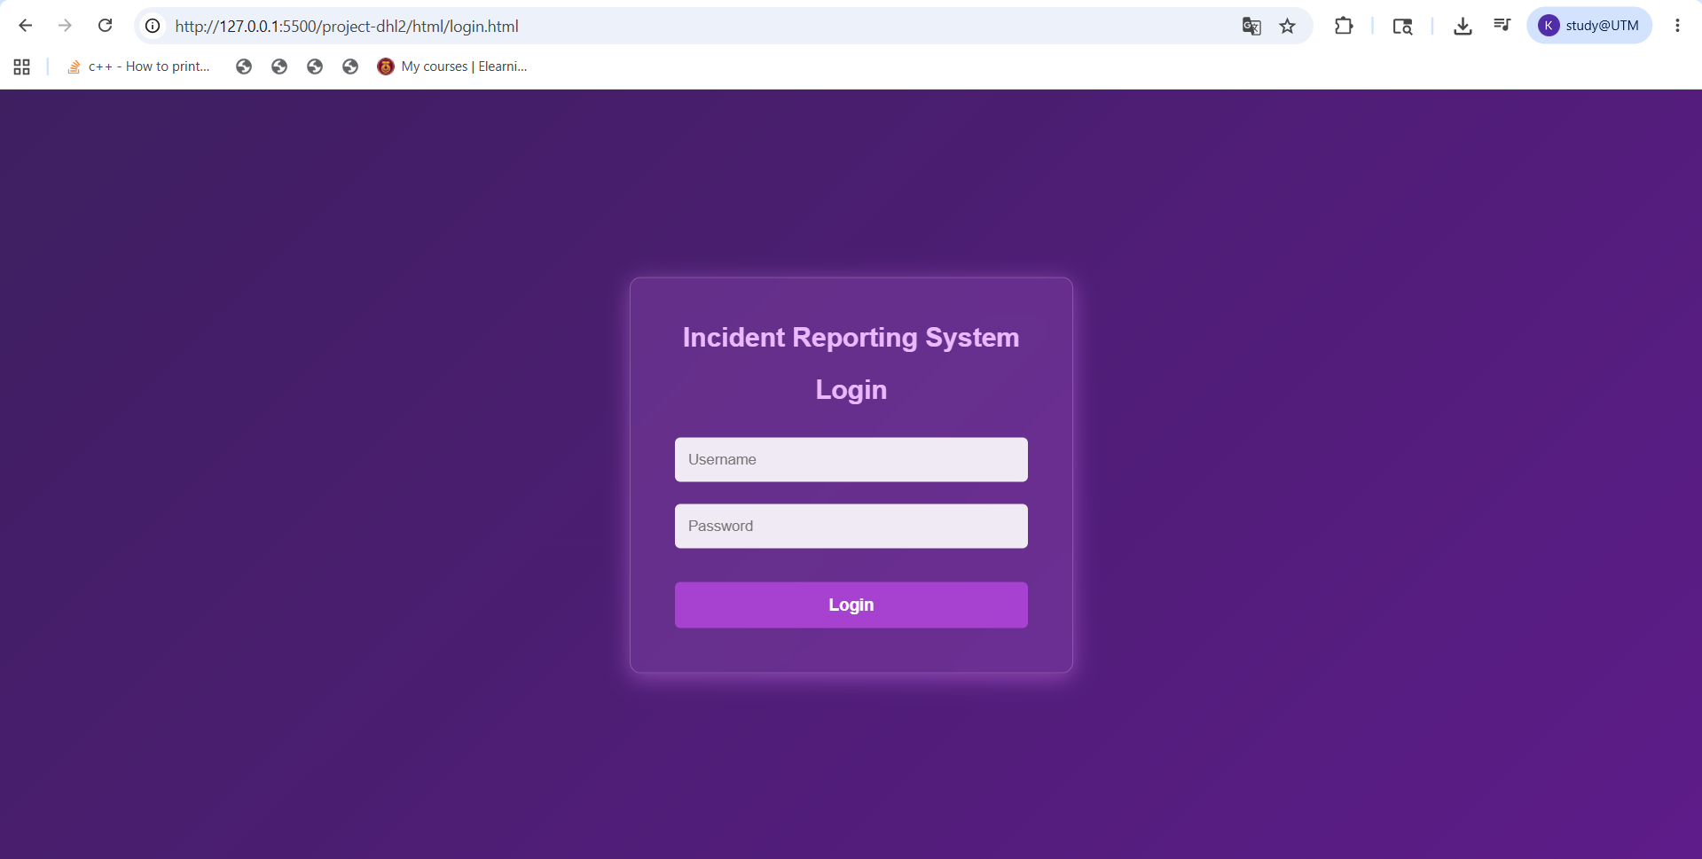

Extra: ONLY IF WANT TO ACCESS AFTER CLOSING VS CODE
Go to project root folder -> Run “npx json-server data/db.json”

